**Diploma in Interaction Design (IxD)**

**What is Interaction Design?**

Here at Interaction Design, we create & design interactive digital media experiences, applying it to the web, products and environments.

We design with our users in mind, applying Design Thinking & the use of Technology to find out about their needs, expectations and emotions.

**Summary of Interaction Design**

**Creating Interactive Products or Environments** & **Developing Immersive Experiences** through the **Integration of Design & Technology**

* Creating Interactive Products or Environments
* Developing Immersive Experiences
* Integration of Design & Technology

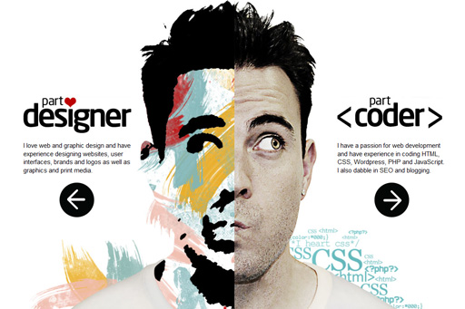

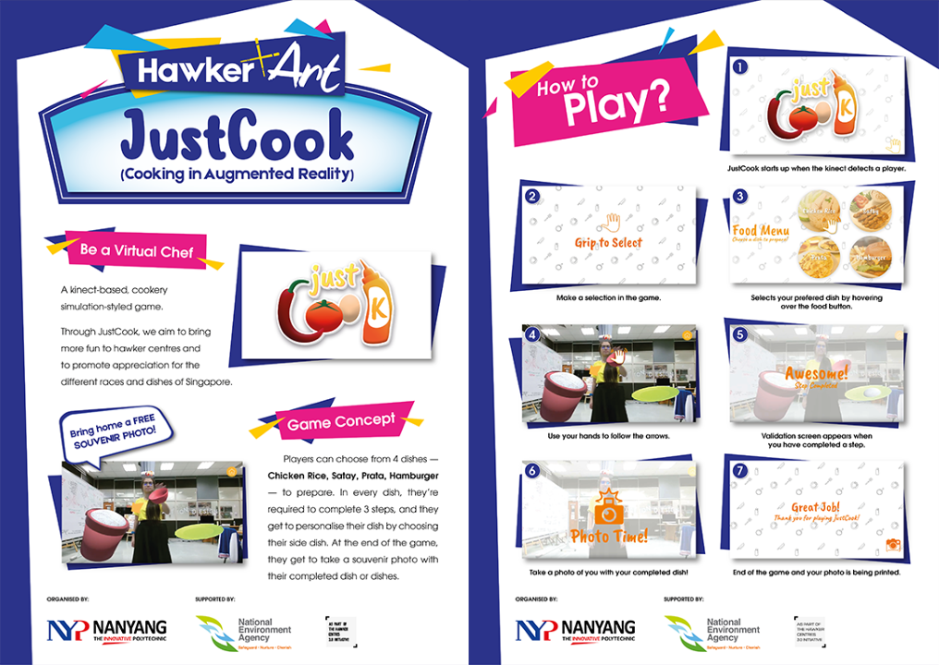

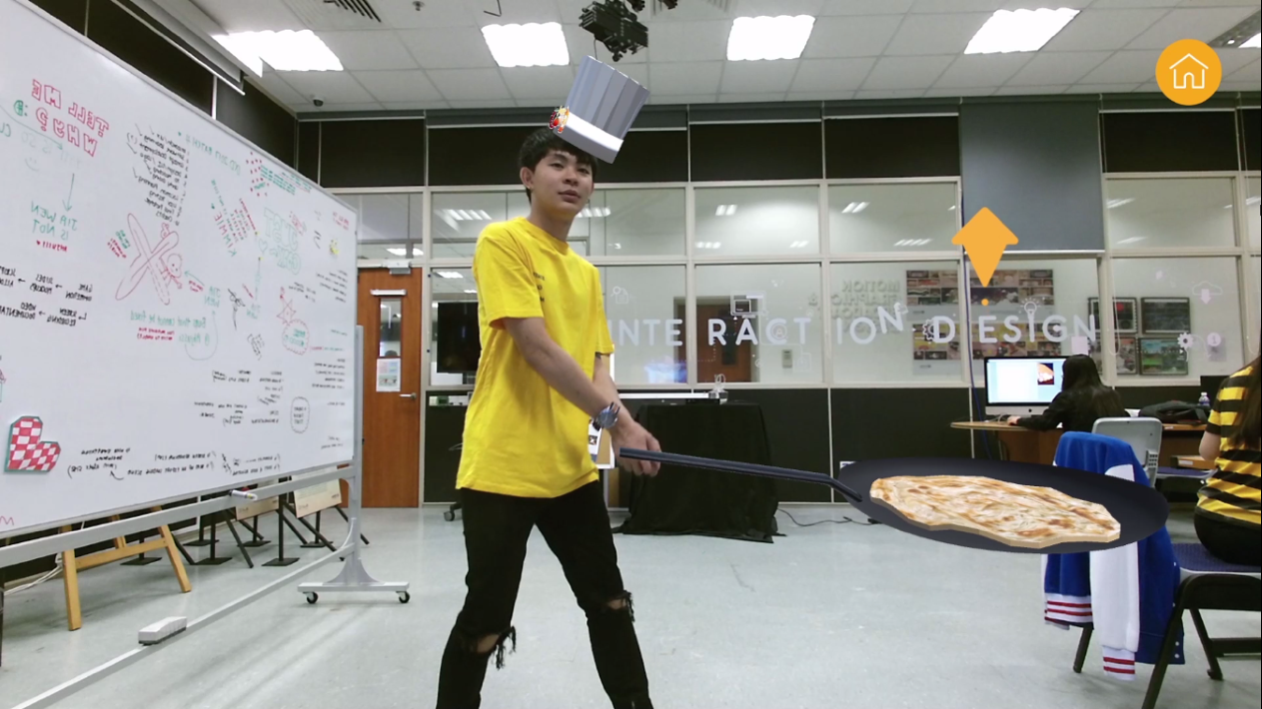

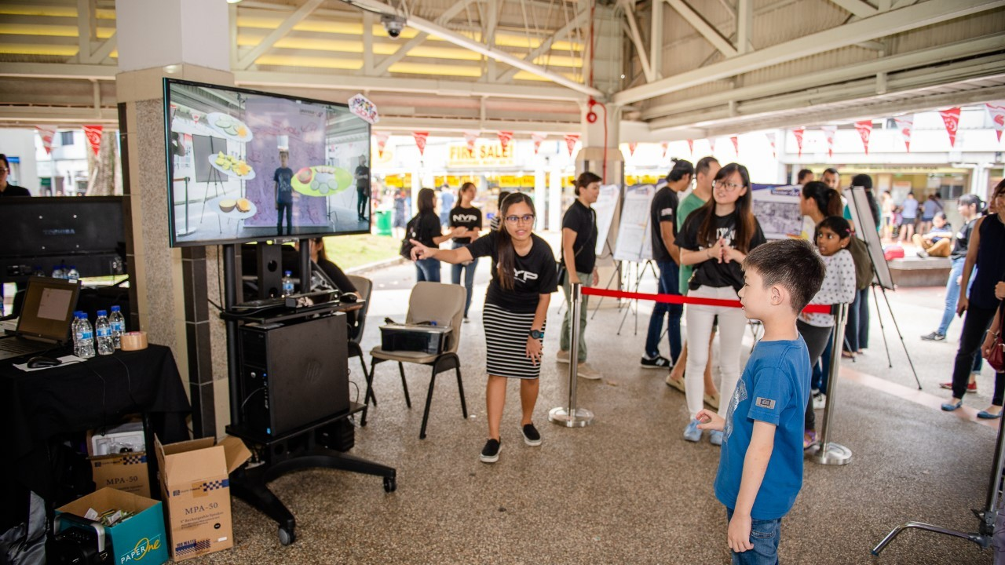

**Project Title: Just Cook**

**Year of Project: 2017**

**Client: NEA**

**Awards / Competitions Won:  
Bronze in UX, Interface & Navigation 2019, Non-Pro**

**Introduction:**

**Just Cook is a Kinect-based, Cookery Simulation-Styled Game created to promote the culture of Hawker Centres in Singapore**

**Interesting Trivia about the Project:**

* Kinect-based, Cookery Simulation-Styled Game
* Created for NEA’s Vibrant Hawker Centre Programme
* Brought to a Hawker near NYP (AMK Blk 724 Central Market)
* Promoting the culture of Hawker Centres
* Making the Hawker Culture more fun & enjoyable
* Appreciating the different races & dishes of Singapore
* 4 Dishes to choose from – Chicken Rice, Satay, Prata & Hamburger
* Required to complete 3 of the dishes’ essential steps
* Personalising their very own dish by selecting their unique side dishes
* Snap a photo with the completed dishes as a souvenir

----------------------------------------------------------------------------------------

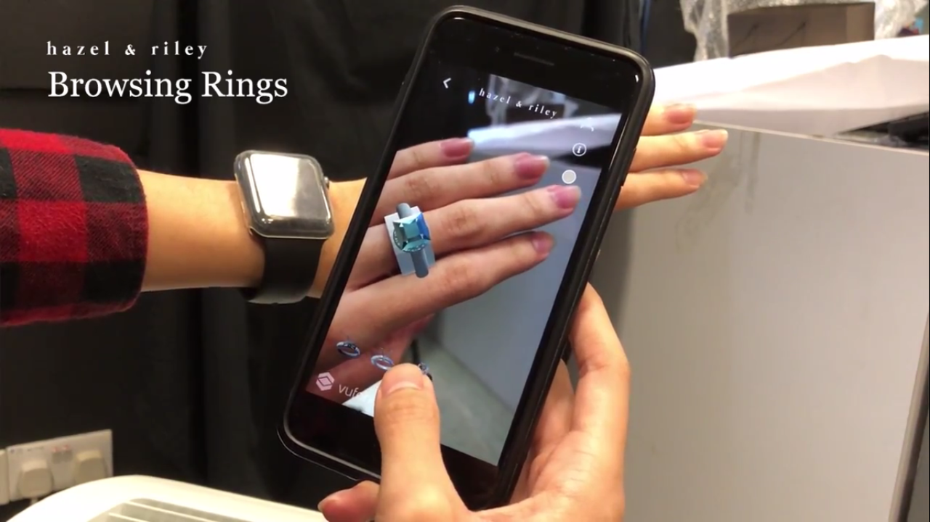

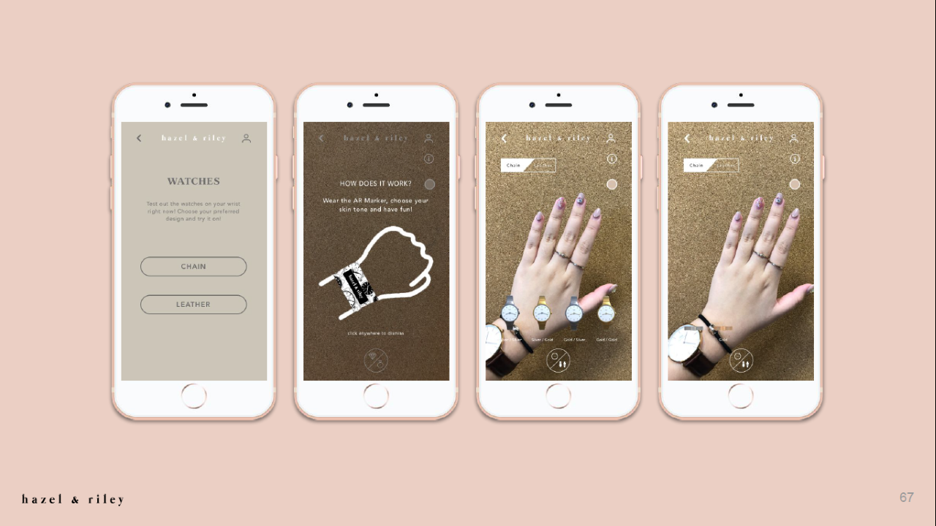

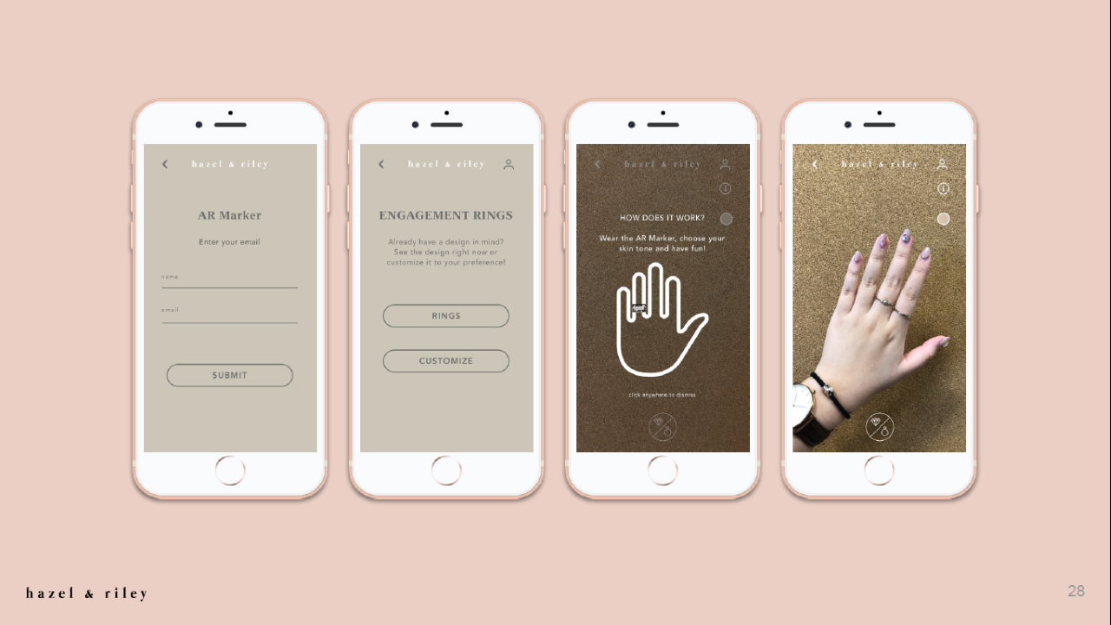

**Project Title: AR Jewellery**

**Year of Project: 2018**

**Client: NIL**

**Awards / Competitions Won:  
- Gold in Innovative Use of Mobile Technology 2019, Non-Pro  
- Bronze in Digital Tools and Utilities 2019, Non-Pro  
- Honorable Mention in Interactive Design 2019, Non-Pro**

**Introduction:**

**AR Jewellery is a mobile application which allows our users to visualise the jewellery of their choice on their hands through the use of Augmented Reality**

**Interesting Trivia about the Project:**

* Allow our users to visualise the selected jewellery on their hands through the use of AR (Augmented Reality)
* Saving our users the trouble of visiting the physical store
* Customising the products to their liking through the application before experiencing it with the AR (Augmented Reality)

----------------------------------------------------------------------------------------

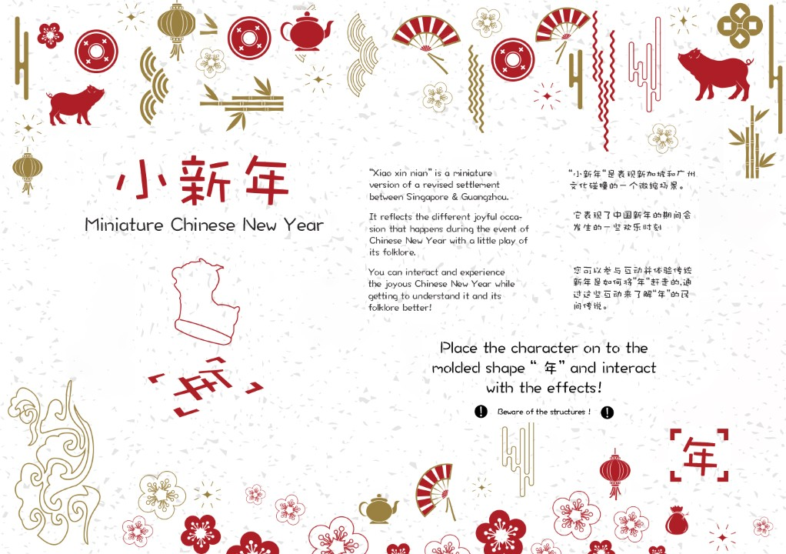

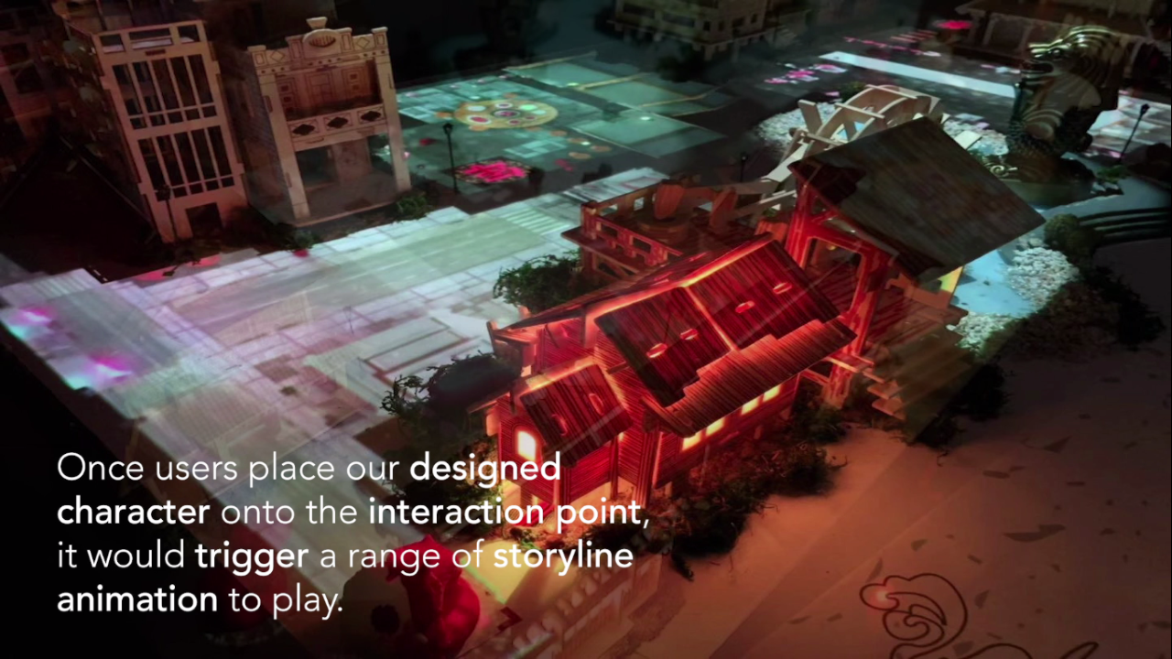

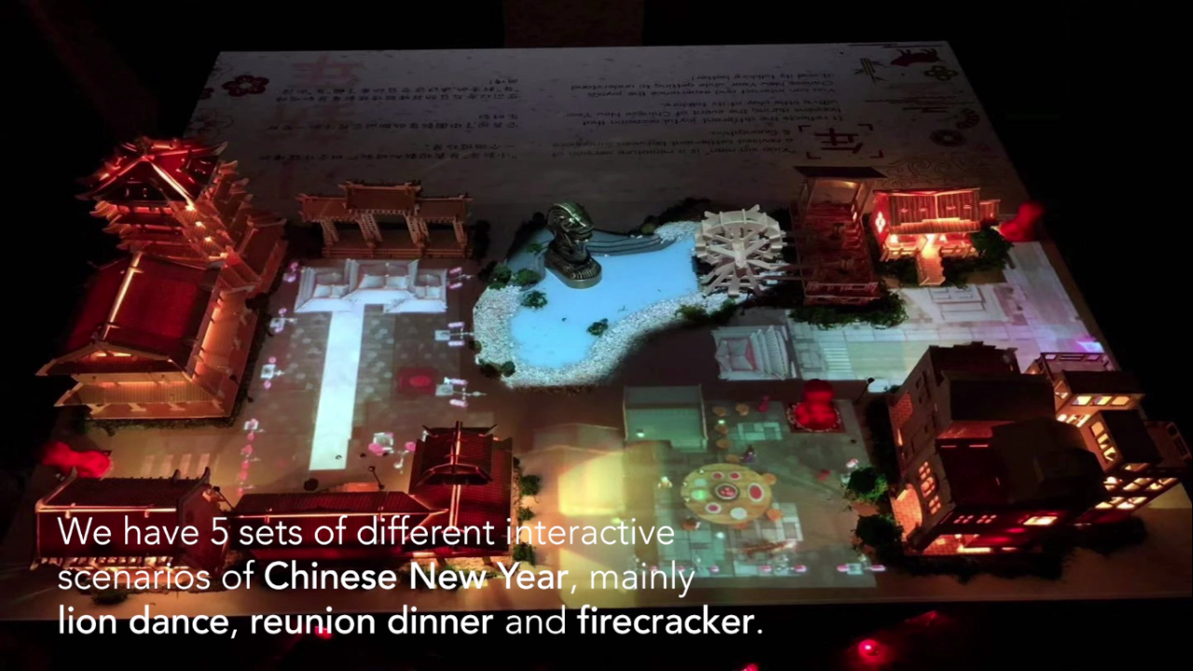

**Project Title: Miniature New Year 小新年**

**Year of Project: 2018**

**Client: NIL**

**Awards / Competitions Won:  
Gold in UX, Interface & Navigation 2019, Non-Pro**

**Introduction:**

**Miniature New Year 小新年 is a project which allows our users to experience & understand the culture of Chinese New Year through the use of Projection Mapping & Sensors**

**Interesting Trivia about the Project:**

* IxD students travelled to Guangzhou for 2 weeks in order to collaborate with students from Guangzhou Academy of Fine Arts (GAFA)
* Allow our users to experience & understand the traditional culture, folklore and practices of Chinese New Year in Singapore & Guangzhou, through the use of Projection Mapping & Sensors
* A projection video will be activated & the model house will be lighted up when the “nian” is placed on any appointed area (“nian” = lion)
* Our IxD students 3D printed the lions and constructed the physical board from scratch all by themselves

----------------------------------------------------------------------------------------

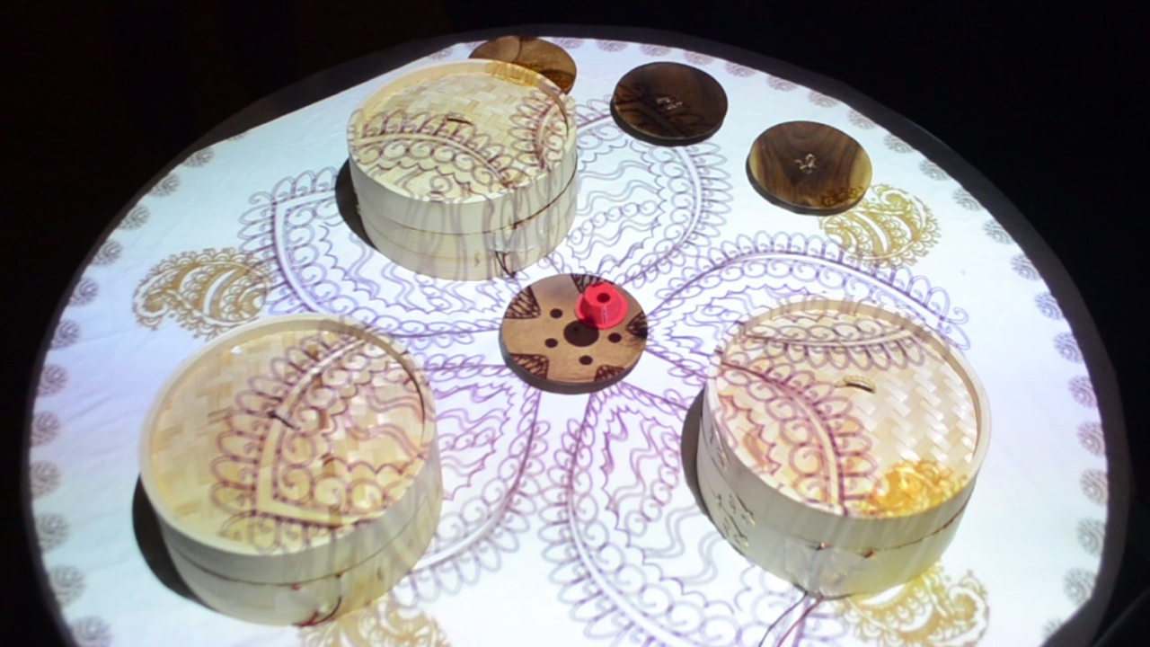

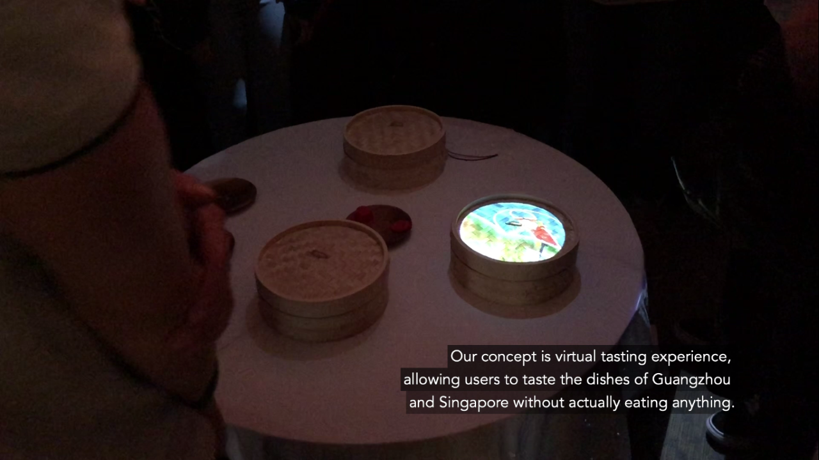

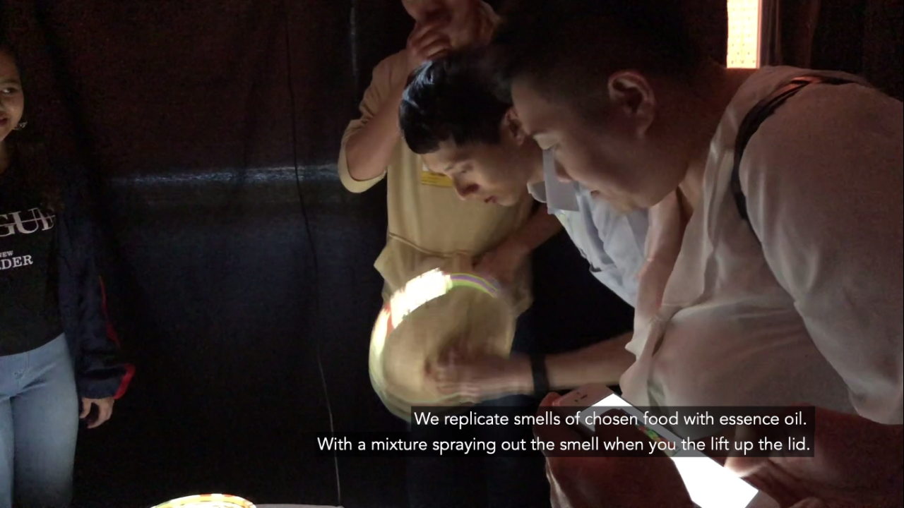

**Project Title: Pin 品**

**Year of Project: 2018**

**Client: NIL**

**Awards / Competitions Won:  
Silver in UX, Interface & Navigation 2019, Non-Pro**

**Introduction:**

**Pin 品 is a project which allows our users to have a virtual tasting experience through the use of audio-visual project stimulation**

**Interesting Trivia about the Project:**

* IxD students travelled to Guangzhou for 2 weeks in order to collaborate with students from Guangzhou Academy of Fine Arts (GAFA)
* Users do not have to actually taste the food to experience it
* A virtual tasting experience, incorporating the sense of taste through the use of audio-visual project stimulation
* Using the sense of smell & the visuals to “taste” the food

----------------------------------------------------------------------------------------

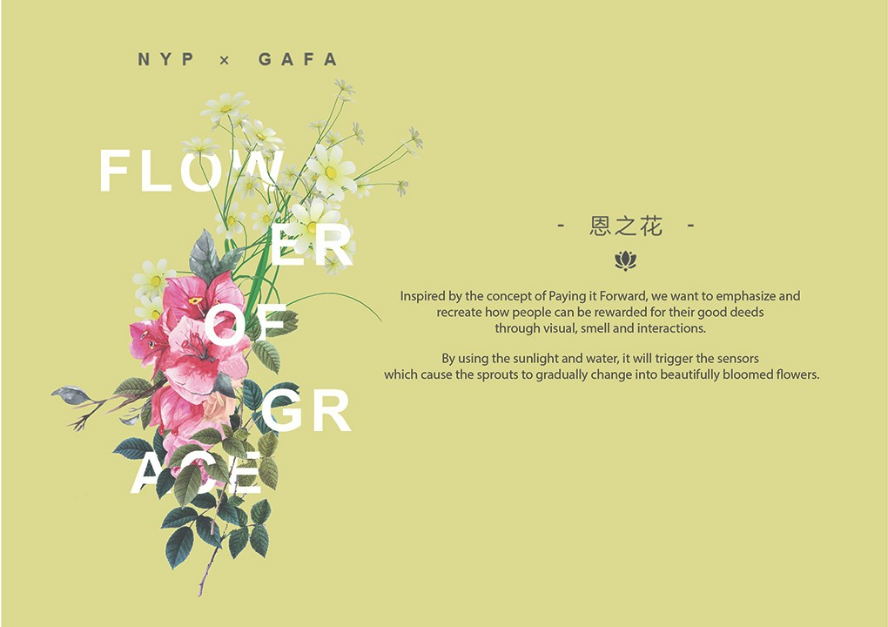

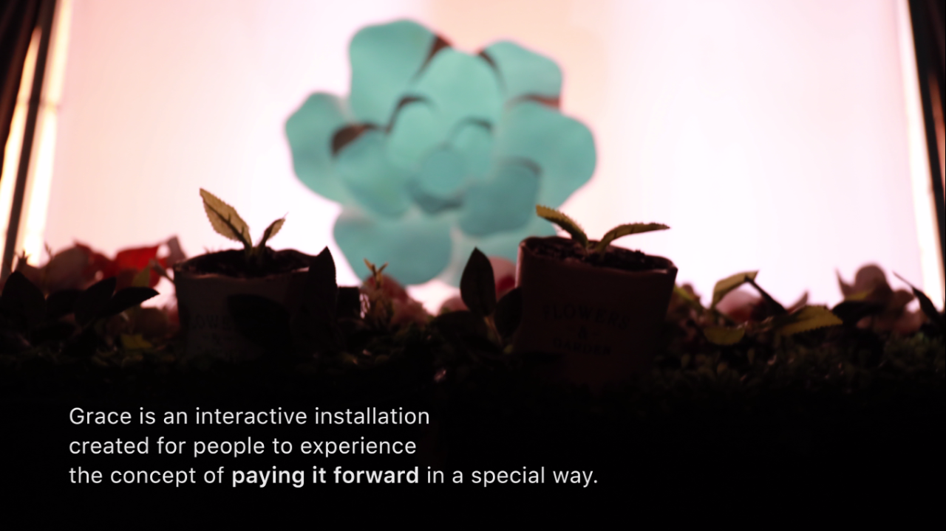

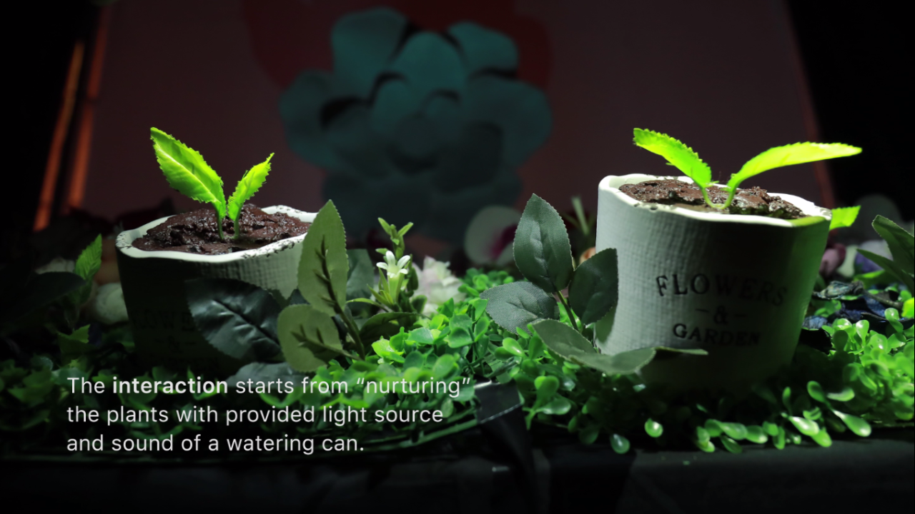

**Project Title: Flower of Grace 恩之花**

**Year of Project: 2018**

**Client: NIL**

**Awards / Competitions Won:  
Bronze in UX, Interface & Navigation 2019, Non-Pro**

**Introduction:**

**Flower of Grace 恩之花 is a project which shows how people are rewarded for their good deeds through the use of projection, visual, smell and interactions**

**Interesting Trivia about the Project:**

* IxD students travelled to Guangzhou for 2 weeks in order to collaborate with students from Guangzhou Academy of Fine Arts (GAFA)
* Inspired by the concept of Paying It Forward
* Showing how people are rewarded for their good deeds through the use of projection, visual, smell and interactions
* A watering can will be used together with the flashlight on their mobile phones to mimic the acts of “watering” and “sunlight”
* It will then trigger the lights, lighting up the different buds & flowers in sequence, directing users to the 3D flower on the wall through the use of projection mapping

----------------------------------------------------------------------------------------

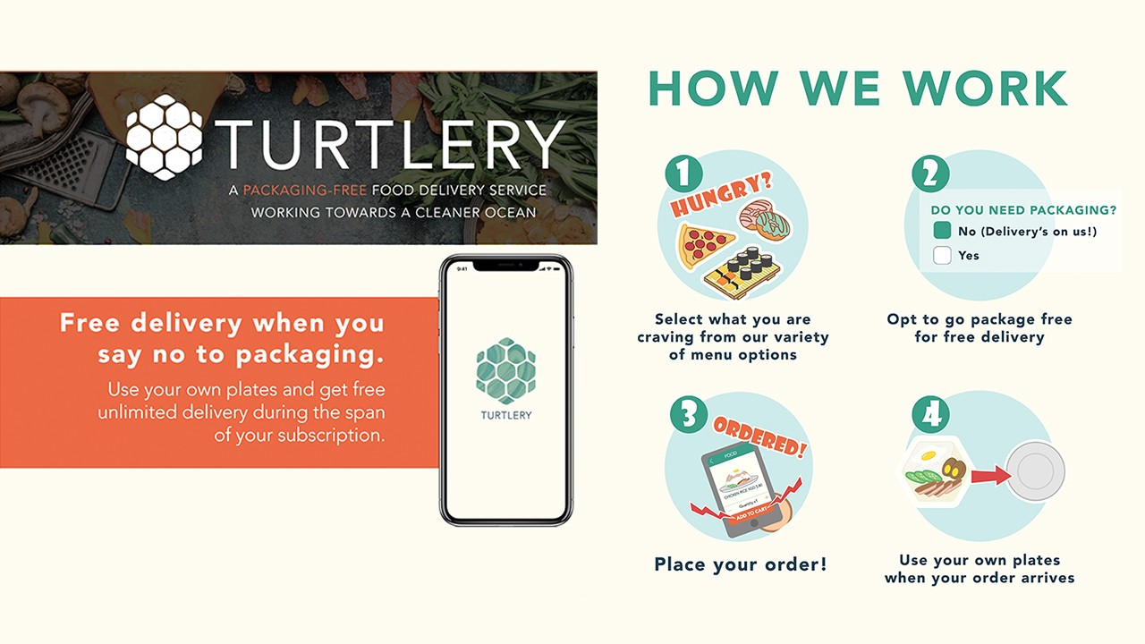

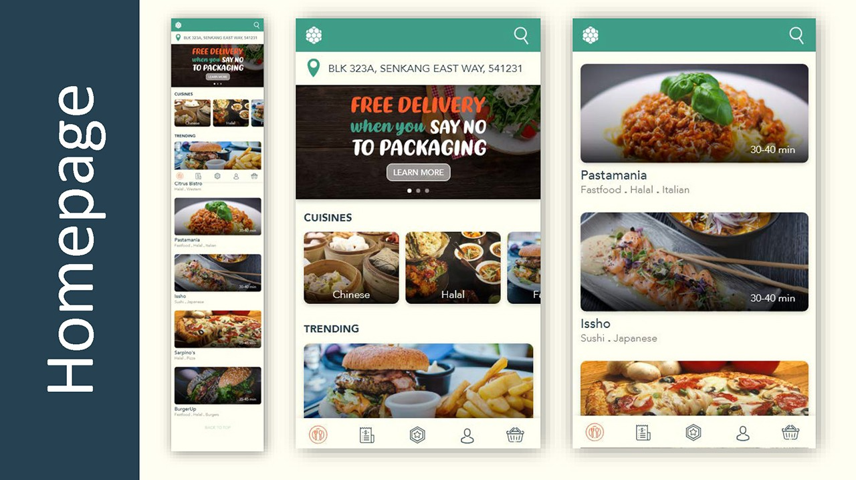

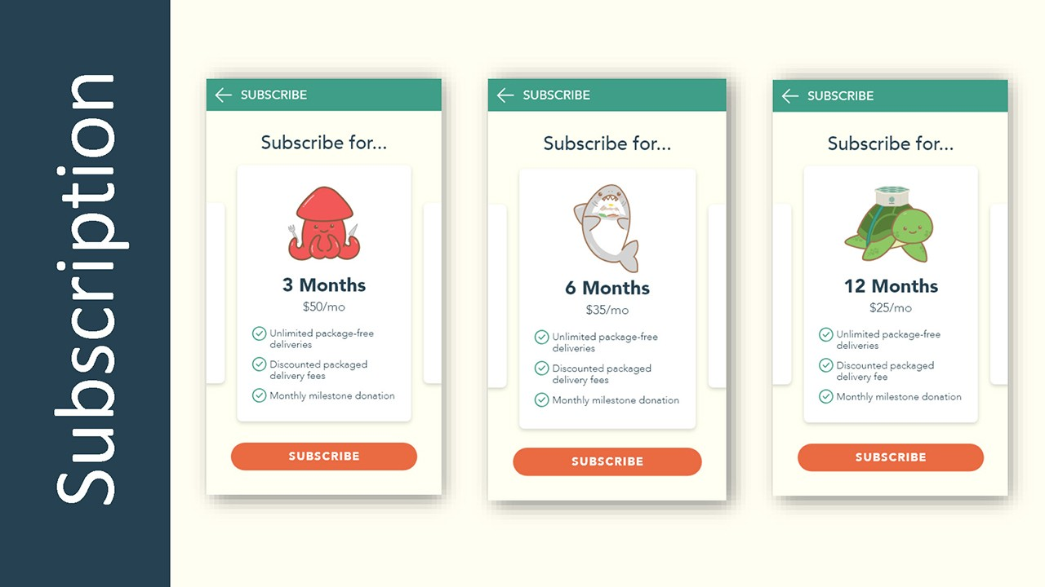

**Project Title: Turtlery**

**Year of Project: 2018**

**Client: NIL**

**Awards / Competitions Won:  
Top Winner in Sustainability Design Competition 2018**

**Introduction:**

**Turtlery is a food delivery mobile application which stores customers’ orders with their own reusable containers and later transferred to customers’ own tableware after delivery**

**Interesting Trivia about the Project:**

* Challenging youths to revolutionize Singapore’s takeaway culture, coming up with creative & sustainable solutions
* Food delivery mobile application with a twist
* Using Turtlery’s very own reusable containers to store customers’ orders
* Delivered & transferred to customers’ own tableware
* Turtlery’s containers are then washed and reused for another delivery
* 15% of profit earned will be donated to NGOs chosen by the customers

----------------------------------------------------------------------------------------

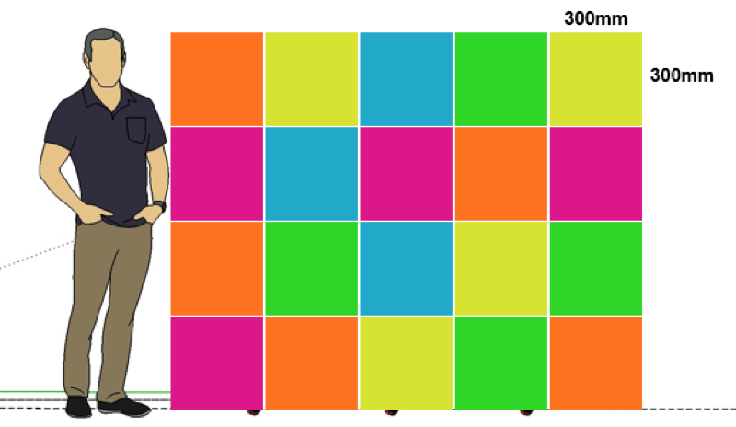

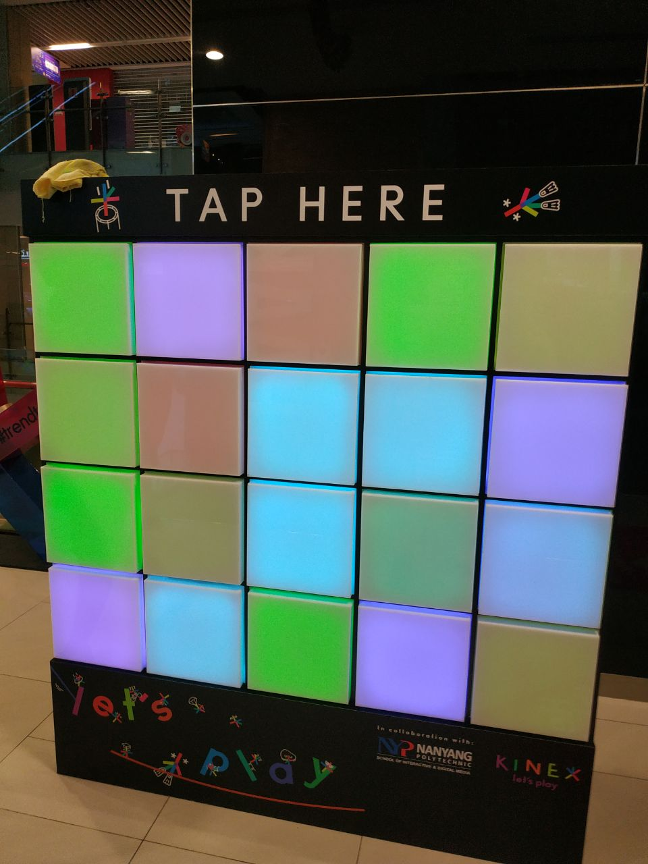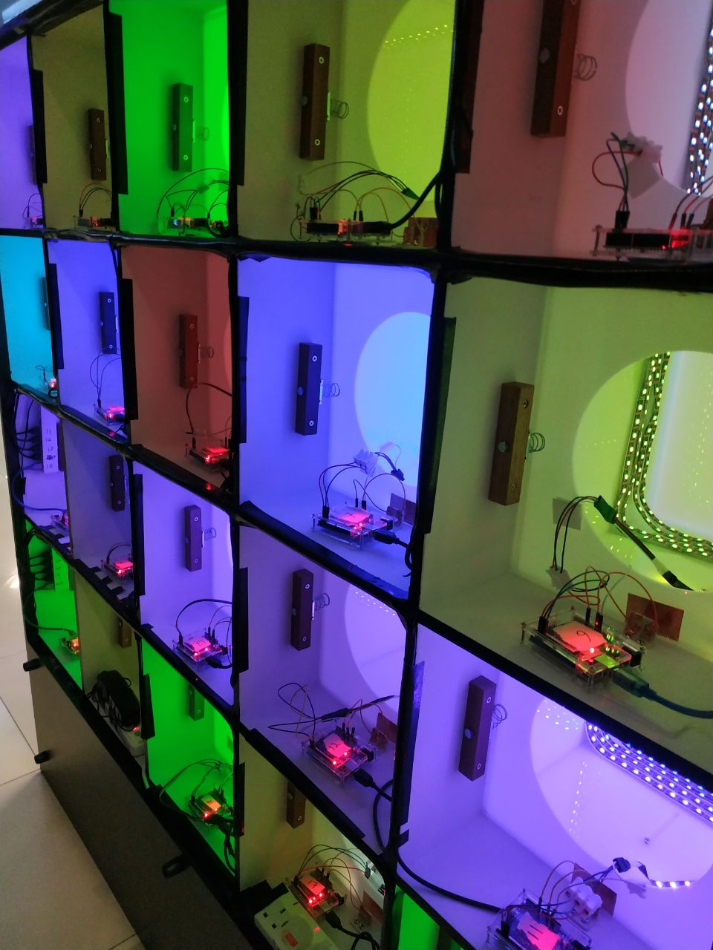

**Project Title: Interactive Wall**

**Year of Project: 2018**

**Client: KINEX (Formerly OneKM mall, by UOL)**

**Exhibited At:  
KINEX Singapore**

**Introduction:**

**Interactive Wall is a playful and interactive installation created to help raise awareness among the public visiting the mall**

**Interesting Trivia about the Project:**

* 3 of our Final Year Students benefitted greatly in terms of Design Thinking & User Experience through their involvement in this project
* Raise awareness and also to showcase our capabilities in User Experience & Interaction Design to the public
* Playful and Interactive installation, part of our Physical Interaction Design (PIXD)
* Our students handled the project themselves, from the Production, Cost & Materials to Maintenance, taking everything into consideration
* For example, Our students have to consider the materials used, whether it can sustain in the long run even after being displayed to the public for a long period of time

----------------------------------------------------------------------------------------

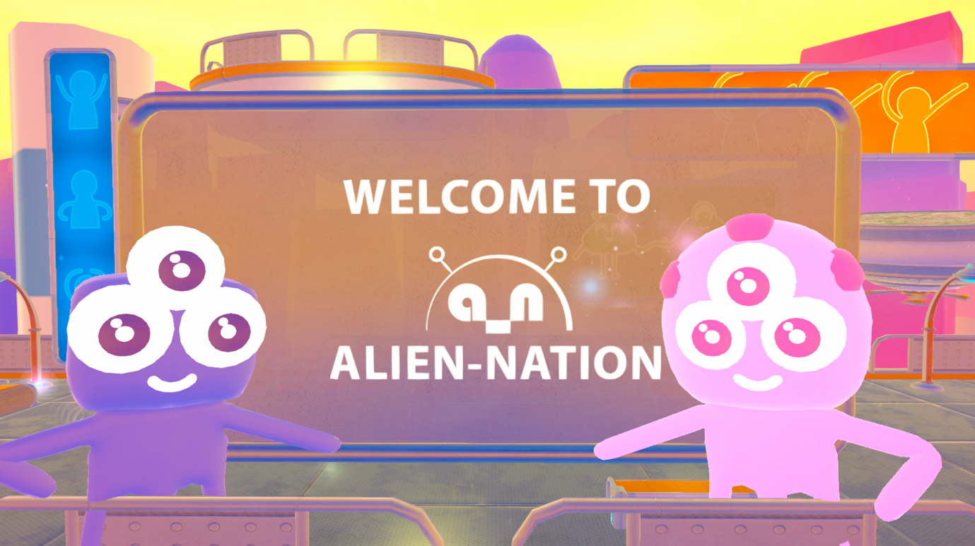

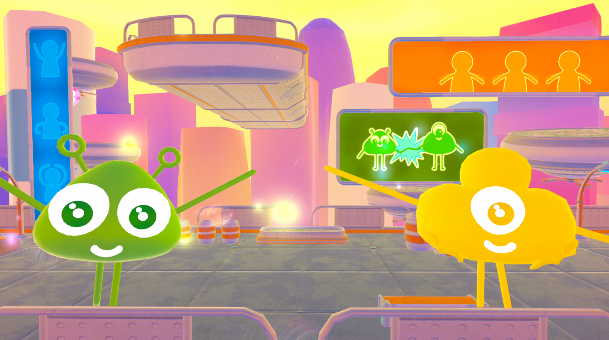

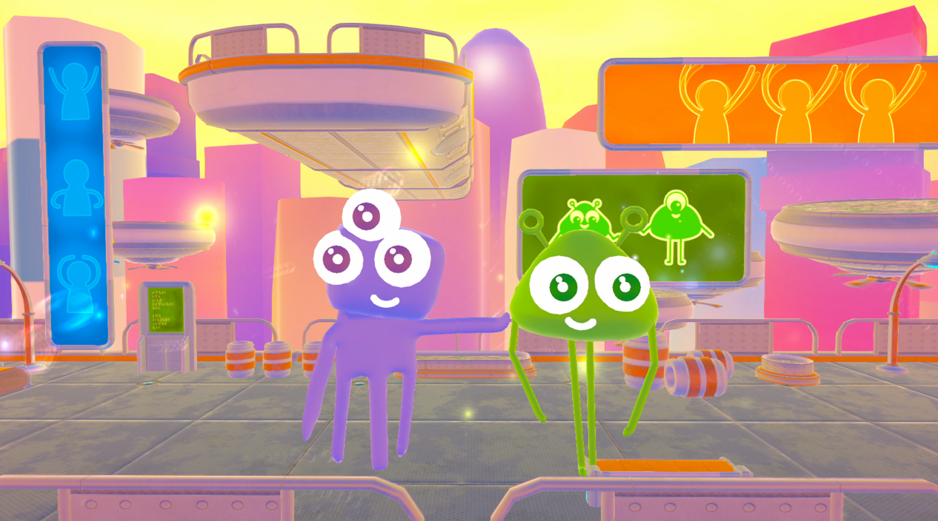

**Project Title: Alien Nation**

**Year of Project: 2017 / 2018**

**Client: Collaboration with Arts Science Museum**

**Exhibited At:  
Singapore Arts Science Museum (19 ~ 29 May 2018)**

**Introduction:**

**Alien Nation is an interactive installation which allow users to become an digital avatar in a colourful animated world where they can control the avatar’s movements through their own body and gestures**

**Interesting Trivia about the Project:**

* Allow our users to become an avatar in a colourful animated world when they stand in front of the installation
* Up to a maximum of 4 users at once
* Uses Kinect’s skeleton tracking to detect the movement of our users
* Users can control the digital avatar using their body and gestures, and also bump into one another to exchange their digital body parts

----------------------------------------------------------------------------------------

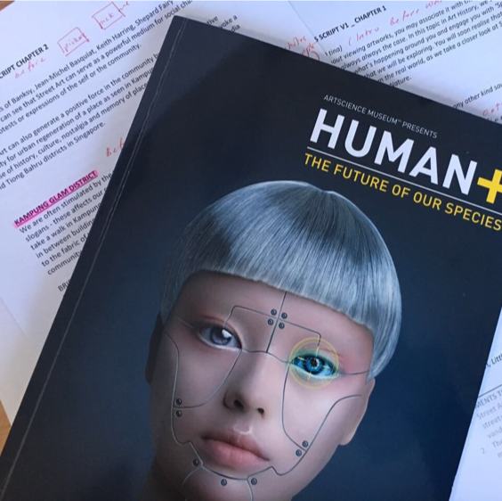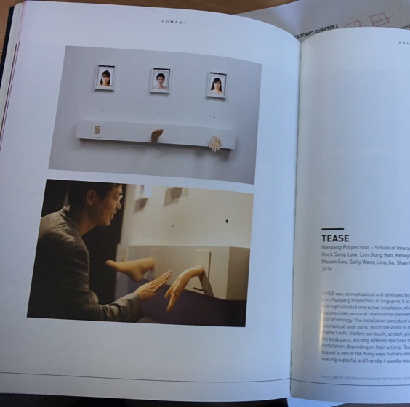

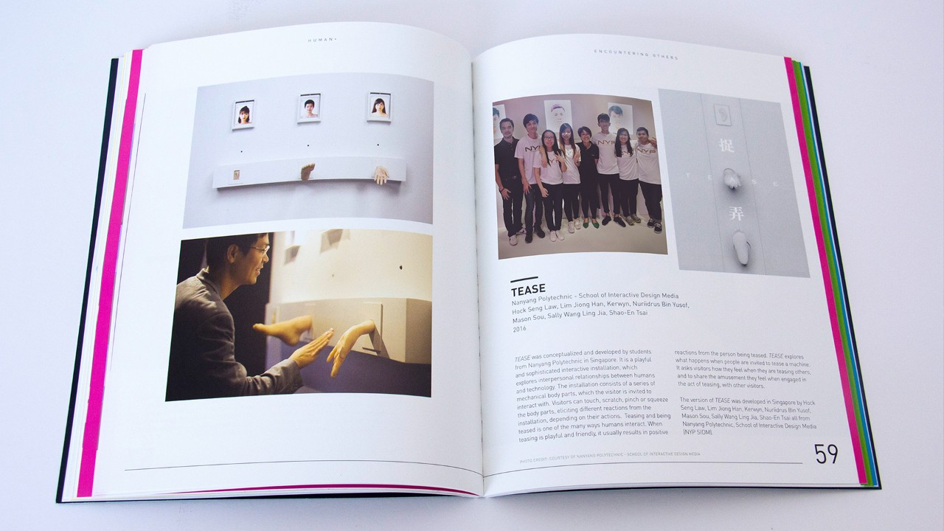

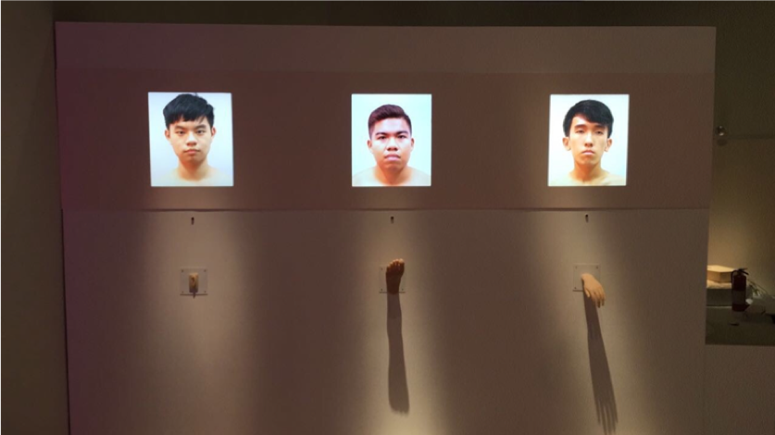

**Project Title: Tease**

**Year of Project: 2016 / 2017**

**Client: Collaboration with Arts Science Museum**

**Exhibited At:  
Singapore Arts Science Museum**

**Introduction:**

**Tease is an interactive installation that consists of a series of mechanical body parts that visitors can touch, scratch, pinch or squeeze to elicit different reactions from the installation**

**Interesting Trivia about the Project:**

* A playful and whimsical interactive installation that explores the interpersonal relationships between humans and technology
* A series of mechanical body parts that visitors can touch, scratch, pinch or squeeze, eliciting different reactions from the installation
* Part of the Human+ exhibition at Art Science Museum till Oct 2017

----------------------------------------------------------------------------------------

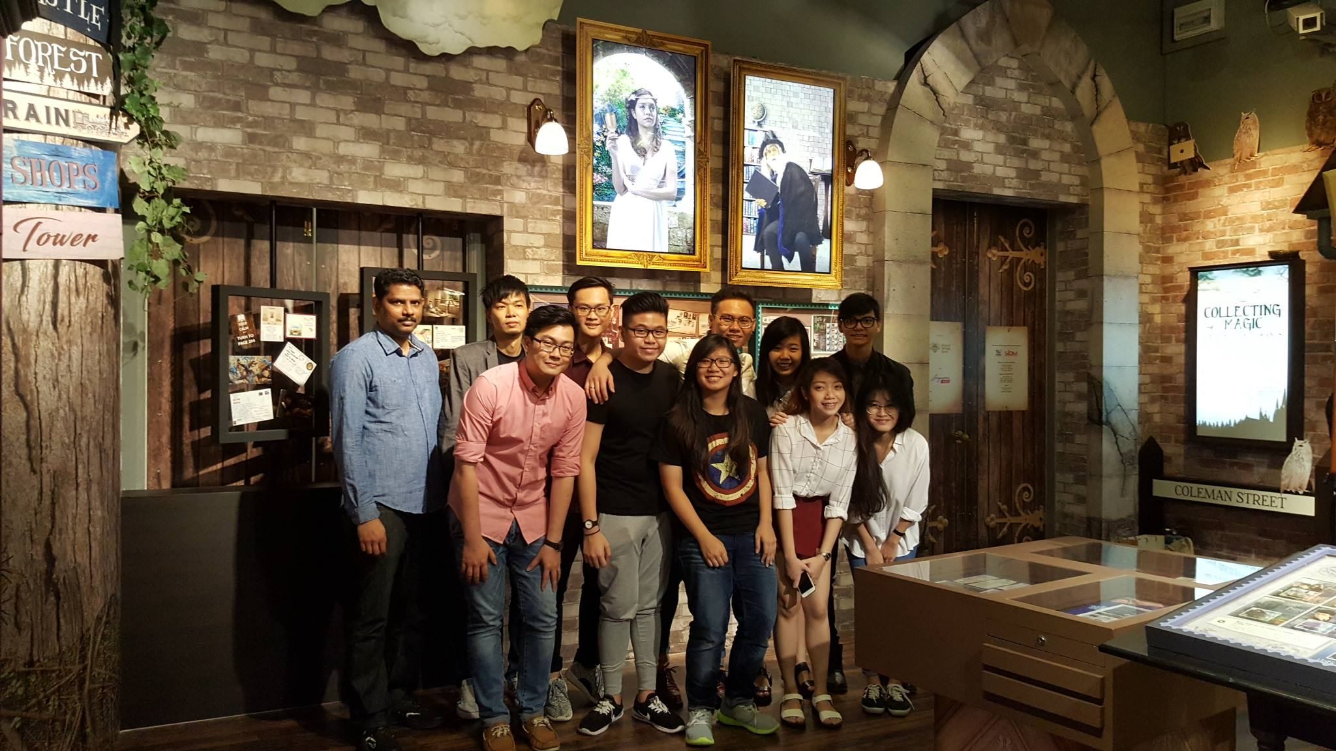

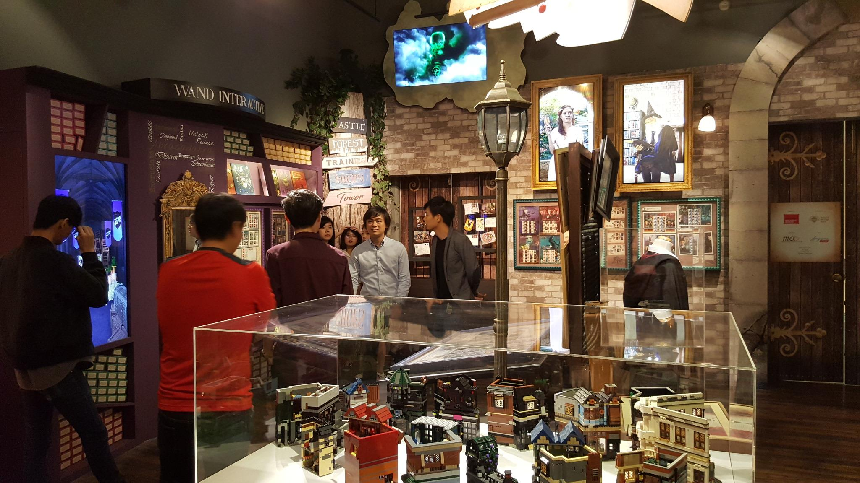

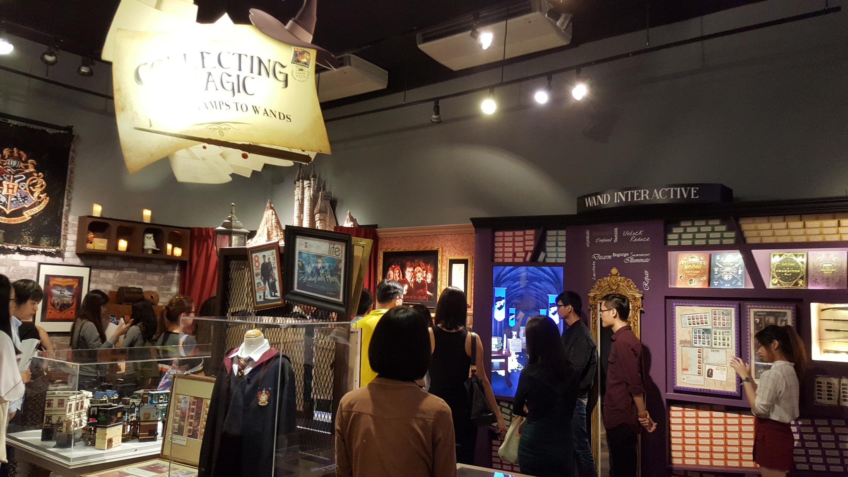

**Project Title: Collecting Magic from Stamps to Wands**

**Year of Project: 2016**

**Client: Collaboration with Singapore Philatelic Museum**

**Exhibited At:  
Singapore Philatelic Museum**

**Introduction:**

**Collecting Magic from Stamps to Wands is a project that consists of several different interactive multimedia exhibits, including Talking Portraits and an Interactive Wand Station**

**Interesting Trivia about the Project:**

* We were invited by Singapore Philatelic Museum to develop interactive multimedia exhibits for its first-ever Harry Potter-themed exhibition
* Working with students from Visual Effects, our interaction Design students created several Talking Portraits and also the Interactive Wand Station
* Our students also helped to create a 3D printed wand for a set of magical stamps where the words would disappear to reveal a picture
* Some components used in the 3D printed wand were Arduino and Accelerometer (Motion Sensor)

----------------------------------------------------------------------------------------

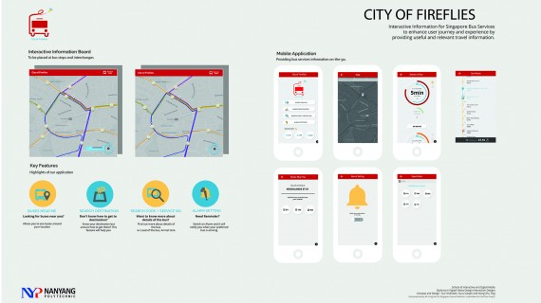

**Project Title: City of Fireflies**

**Year of Project: 2016**

**Client: NIL**

**Awards / Competitions Won:  
Finalist at Interaction Awards 2016**

**Introduction:**

**City of Fireflies is an Interactive Mobile App created for bus commuters which provides the accurate timing of buses and predicting the upcoming needs of the users**

**Interesting Trivia about the Project:**

* Commuters in Singapore rely on Mobile Apps, Information Boards and Interchanges for travelling information
* Based on the research & date provided by LTA (Land Transport Authority), the team proposed an Interactive Mobile App
* Optimising the user experience of bus commuters by simplifying the extraction & transmission of information
* Providing users the accurate time & also factoring in machine learning to predict the upcoming needs of the users

----------------------------------------------------------------------------------------

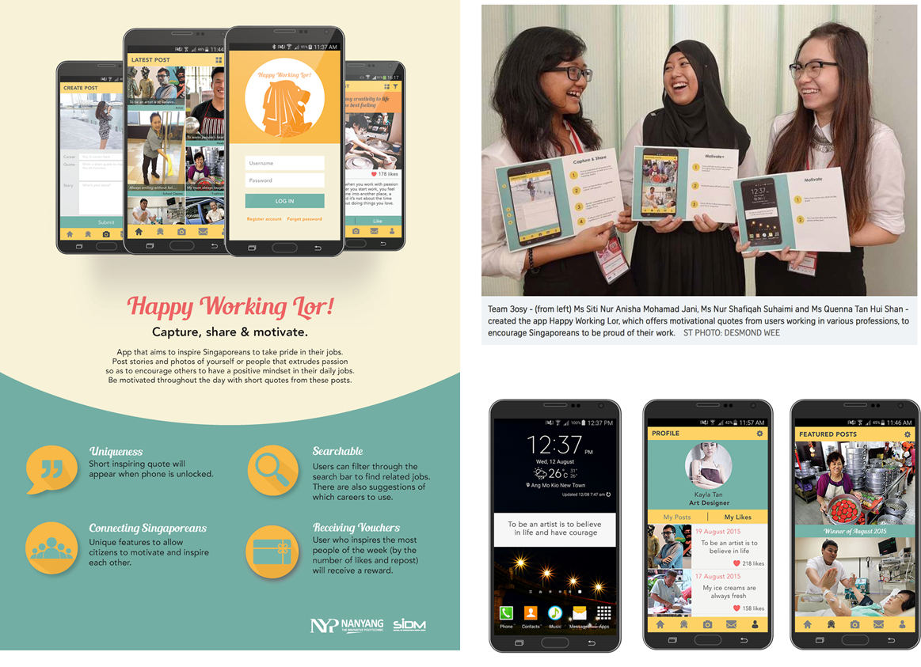

**Project Title: Happy Working Lor**

**Year of Project: 2015**

**Client: NIL**

**Awards / Competitions Won:  
Splash Awards 2015 Winners**

**Introduction:**

**Happy Working Lor is an Mobile Application created to encourage individuals to take pride in their jobs, submitting their own pictures online to keep track of their own happy moments**

**Interesting Trivia about the Project:**

* Collaborative platform based online
* A Mobile Application encouraging individuals to take pride in their jobs
* Aims to motivate & inspire Singaporeans to have a positive attitude & mindset towards working, bringing out the spirit of SG50 & SkillsFuture
* Users can submit their own pictures with captions, short stories or inspiring quotes to highlight interesting aspects of either their work or others
* Keeping track of their happy moments & also of those who inspired them